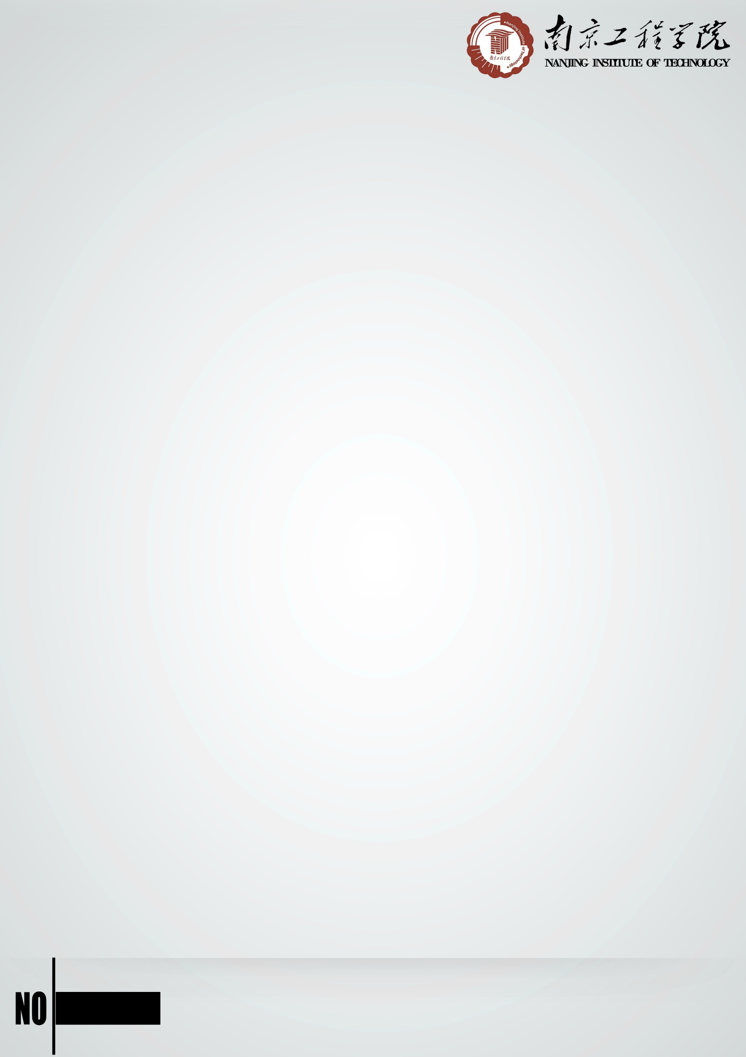

Sea is the second largest space after land among the human development of the four strategic spaces (land, sea, air, sky). It is the strategic development base of biological resources, energy, water resources and metal resources. Also, it is the most practical and has the most development potential of four strategic spaces. It plays a direct and great supporting role in China’s Economic and Social Development. As the assistant of human exploration and development of the marine, underwater robots will show their use in many aspects among this field. Underwater robot is a kind of system with artificial intelligence, highly autonomous ability, memory and learning ability, which can adapt to changes in the external environment.

The key technology in the research of ROV at the present stage includes:

**1. Motion Control Technology:**

ROV’s Motion Control Technology is the premise and guarantee of completing provided tasks.

**2. Navigation and Positioning Technology:**

The accuracy of Navigation and Positioning is essential to successful execution of ROV tasks.

**3. Vision Sensing Technology:**

ROV depends on all kinds of sensors to acquire information about the target and the environment under water. The most intuitive information will be from the vision sensor, which can make data visualized and give us intuitive results.

**4. Underwater Moving-body Design:**

In order to reduce the cost and meet the needs of the development use of ROV, we must break the obstacles through the design of underwater moving-body design.

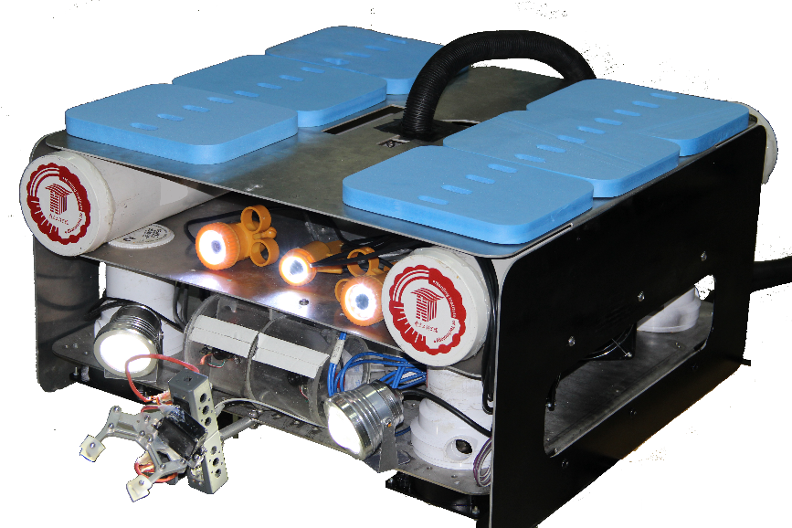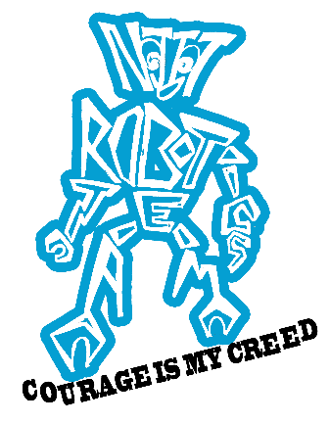

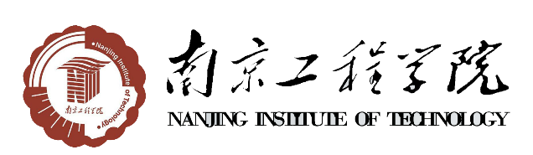

1





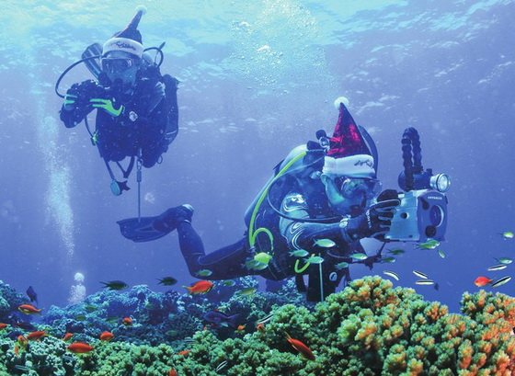This is the first time for our college to participate in the underwater robot competition. Pioneer is based on the mechanical automatically balancing system framework, which can complete the complex motions under the surface of the water. The design content of the whole ROV includes: mechanical arm completing many tasks, the pressure cabin meeting the requirements of depth and circuit installing, binocular vision distance measurement sensor with high precision, attitude sensor based on balancing algorithm, motor propulsion system based on the speed, 3D vision system based on the tasks and control algorithm based on sensor information fusion.

In the Last year’s competition in the NASA, we saw the air diving in the exhibition. We are inspired by this, why can't we build a similar thing?

However, instead of the people inside, we can only have one robot. It is the robots rather than human that can estimate the danger in the deep sea, providing a flexible ROV settings.

And we really learned a lot in the regional contest in Hong Kong. And that was the first time for us to feel such a real international contest. ROVs are so impressive for us! Especially, the one made by Hong Kong University of Science and Technology was so big and really had an original style. So we thought that we can also make something special like them.

.

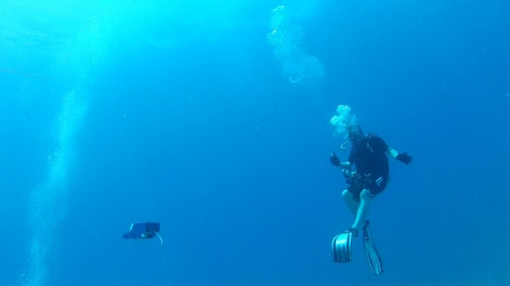



|  |  |  |  |  |
| --- | --- | --- | --- | --- |
| Item No | Item Name | Quantity | Unit Price(RMB) | Total Price(RMB) |
| 1 | 3axis gyroscope+3axis accelerometer MPU6050 | 5 | 13.8 | 69 |
| 2 | Constant pressure water supply pressure sensor 60KPa | 1 | 175 | 175 |
| 3 | 6 inch color monitor underwater camera | 4 | 500 | 2000 |
| 4 | Mechanical arm | 1 | 97 | 97 |
| 5 | USB extender 60meters | 2 | 60 | 120 |
| 6 | [three-blade propeller P40mm*D57mm Φ](http://dict.baidu.com/s?wd=three-blade%20propeller) | 10 | 7 | 70 |
| 7 | [water joint](http://dict.baidu.com/s?wd=water%20joint) | 50 | 2 | 100 |
| 8 | [electromagnet DC 12V](http://dict.baidu.com/s?wd=electromagnet) | 2 | 55 | 110 |
| 9 | remote control | 1 | 380 | 380 |
| 10 | High power DC power supply converter 48Vto12V | 5 | 155 | 775 |
| 11 | Metal gear steering gear MG996R | 4 | 51 | 204 |
| 12 | USB camera | 2 | 98 | 196 |
| 13 | [epoxide-resin glue](http://dict.baidu.com/s?wd=epoxide-resin%20glue) | 1 | 90 | 90 |
| 14 | Waterproof cable connector(2 pin) | 20 | 2.87 | 57.4 |
| 15 | Waterproof cable connector(4 pin) | 20 | 2.87 | 57.4 |
| 16 | Rigid coupling | 8 | 10 | 80 |
| 17 | Cooling fan | 8 | 30 | 240 |
| 18 | Metal protective net | 8 | 1 | 8 |
| 19 | fluid location transmitter | 2 | 100 | 200 |
| 20 | water pump | 8 | 150 | 1200 |
| 21 | Underwater lamp | 2 | 40 | 80 |
| 22 | The infrared emission tube | 50 | 0.2 | 10 |
| 23 | Electronic compass module | 1 | 62 | 62 |
| 24 | step-down transformer | 5 | 15.5 | 77.5 |
| 25 | Acrylic tube | 1 | 129 | 129 |
| 26 | MAX3485 | 30 | 0.7 | 21 |
| 27 | The automobile connector terminal | 100 | 0.4 | 40 |
| 28 | resettable fuse (50 Amp) | 50 | 0.3 | 15 |
| 29 | resettable fuse (10 Amp) | 50 | 0.3 | 15 |
| 30 | swimming pool | 2 | 5000 | 10000 |
| 31 | 485 signal wire | 30 | 2.15 | 64.5 |
| 32 | ISP wire | 50 | 0.8 | 40 |



The ROV is a robot body who can complete intricate actions under the surface of the water, whose adjustment of posture is the most difficult in a complex underwater environment. In order to meet the basic requirements of the robot attitude algorithm, well-designed mechanical structure is the basic guarantee of good completion

Buol

Steel plate

Frame diagram

Buoyancy

Gravity

In order to meet the balanced design of the robot, the equilibrium structure design and algorithm design are its two complementary aspects. The main feature of a self-balancing control system most difficult to resolve is to control it within a certain range by using the angle of vertical direction or the displacement of the horizontal direction as the control object. Control system with center of gravity above and fulcrum below we see in the actual is self-balancing control system. For so we need to design an open box-shaped frame. Aluminum material is preferably the design materials because of its lightness, durability and cost efficiency, which can ensure the members of the team to complete largest number of milling and cutting at the scene. The following aspects needed to be considered in the design process: try to complete the job of the match between Buoyancy and gravity with steel plate being under the floats to make the center of gravity lower and system more stable; try to ensure the ROV more stable when the center of gravity change in the course of the completion of the tasks.

**M机**

**M机**

**M**

**M机**

Motor

Motor

Motor

Motor

MC

Frame design diagram



|  |  |  |  |
| --- | --- | --- | --- |
| Experiment  Num | Material | Thickness | Meet the  need or not |
| 1 | plastic | 1mm | no |
| 2 | plastic | 2mm | no |
| 3 | aluminum | 1mm | no |
| 4 | aluminum | 3mm | yes |
| 5 | steel | 1mm | no |
| 6 | steel | 2mm | yes |

At first, when we wanted to determine the material and thickness about waterproof circuit box, we made a lot of experiments, and results are listed below. Analysis showed that aluminium sheet was easy to be machined down. Referring to the result of experiment, we determined to use aluminium sheet(3mm) to make the waterproof circuit box.

We put it under 6 meter of water to test the pressure, rigidity and waterproof. And we found that it could work. The shape of waterproof circuit box has quite a complicated structure. For completing it, we used the technic of weld and made it in the workshop in our school. We wasted a lot of time to design and construct the box before we went to Hong Kong, but we didn't get good results. And we still didn't have the confidence about waterproof when we complete the regional contest. So we changed the scheme to make sure that it can truly waterproof.

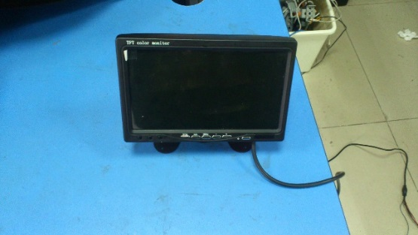In the 3D world that people can see, we are allowed to determine the distances between objects. However, this effect is not transmitted to the camera. The plane pictures do not include the object distance information and its complicated work. When we control the ROV through the stereo vision system, one of the additional features is to provide the driver programme and the depth perception. When we perform tasks (such as grasping and placing things), the operator is made to allow to control the ROV more easily. The 3D vision system makes stereo camera in the ROV head to get the video feedback.

Propulsion system selects eight pumps with 12V DC voltage. Four of them are placed vertically, respectively positioned in the four edges of ROV. So that it can provide vertical thrust, making the ROV keep level under water. The other four are horizontally arranged at the bottom of the ROV, making it a 90 degree vertical. The operator can make the ROV move back and forth and left and right through the control of the four pumps.

We choose plastic materials to complete the competition. The blades are housed in a plastic tube, and then have grilles to protect the propeller. It enables the blades not to rust in the water and can provide a very good acceleration and twisting resistance.

We used plastic propellers in the regional contest, because we thought plastic won't get rust in the water. But we found that the propulsive force was not enough, so we decided to change all of them to aluminium propellers, which are bigger and harder.

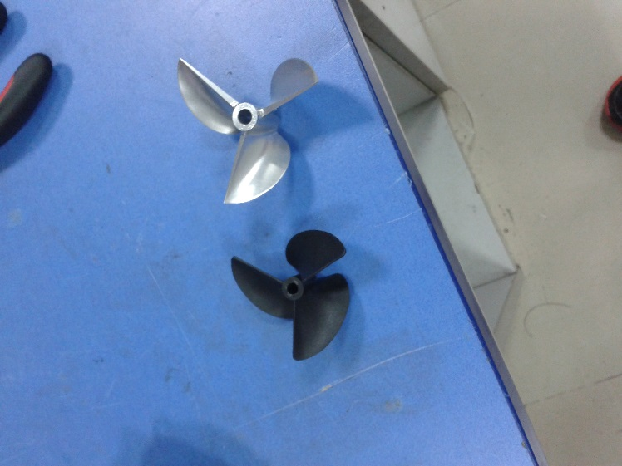 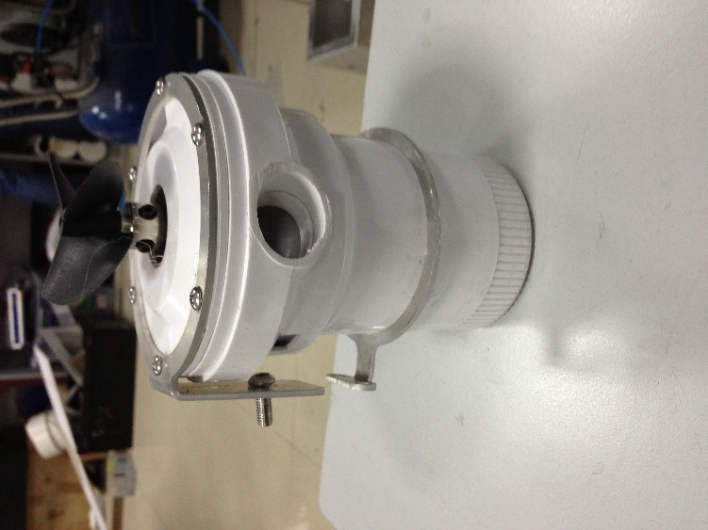

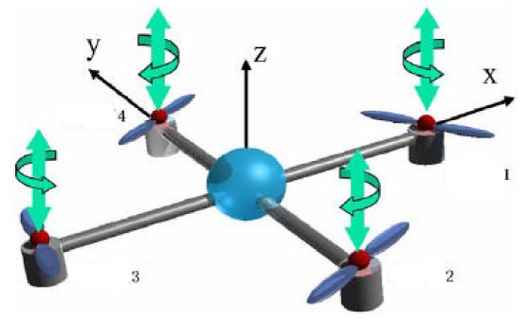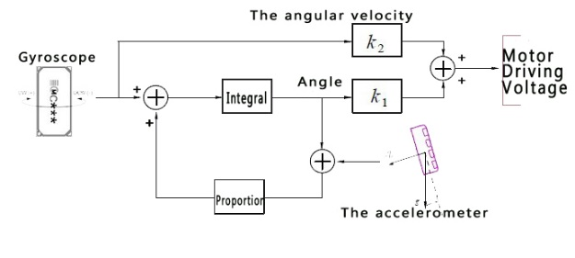The choice of direction sensors is 16 bit A/D three axis gyroscopes and three axis accelerometer MPU-6050. Compared with many other plans, it reduces the problems of the difference between the combination of gyroscope and accelerator axis difference, which reduces the large amount of packing space and can accurately track the fast and slow motion.

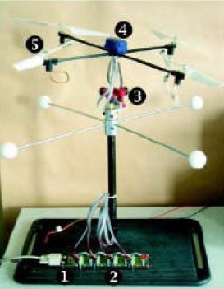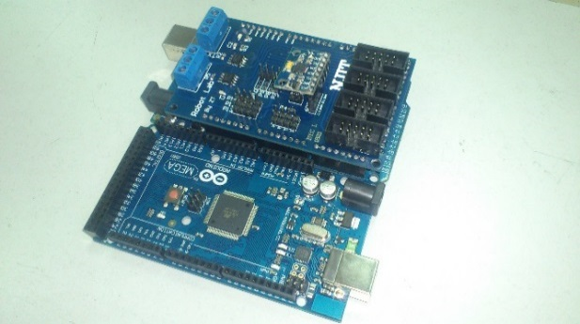The principle of gyroscope is that it will not change, when the rotating axis of a rotating object is not influenced by external forces.

Accelerometer is one of the basic measurement components of inertial navigation and inertial guidance system. The accelerometer is essentially an oscillation system, installed inside the motion vector, and it can be used to measure carriers’ motion acceleration.

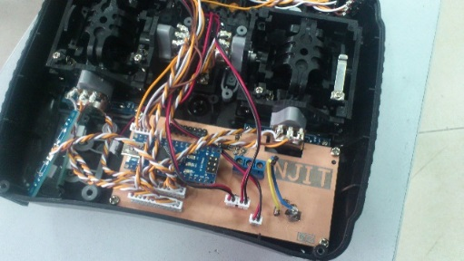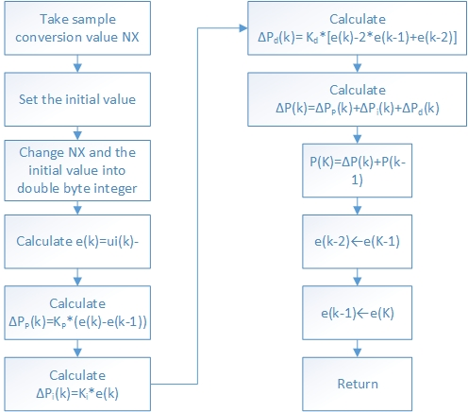We use the direction sensor to detect the angle of plane of the ROV and the horizontal plane. According to the angle, we can control the rotation speed of four propeller motors in the vertical direction to eliminate the angle differences. Combined with the gyroscope signal and the direction of the gravity acceleration signal, the initial attitude control logic come out. According to the hydraulic device, we can measure the depth of the ROV in the water. Then we make the value fed back to the remote control. The remote control is based on the given value and feedback value, controlling the depth of the device in the water.



The system implementation method is comparative. Because the length of brick is known, so we can get the length of object as long as comparing object and the brick to get the proportion coefficient and multiplying the length of brick. First, we take a picture and set up coordinate system. Because the picture is made from pixel, so we can use 4 points to get the coordinate and calculated the length of object.

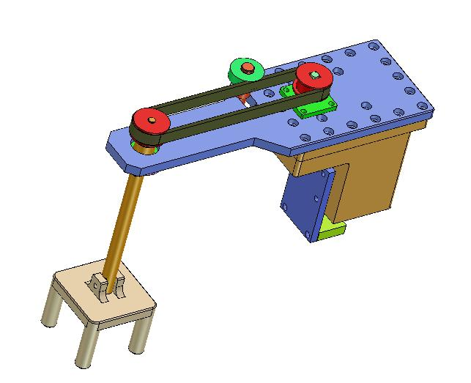The mechanical arm is a very important part of the ROV design. The purpose is not only to observe simply, including interaction with its environment, but also to accomplish the corresponding tasks. The design of mechanical arm of the Deep-Sea Explorer is relatively simple. It can complete the motion of 360 degrees in the horizontal and vertical directions, as well as grasping operation. In the process of the mechanical arm’s operation, we can see the whole motion process of mechanical arm through the camera feedback image.

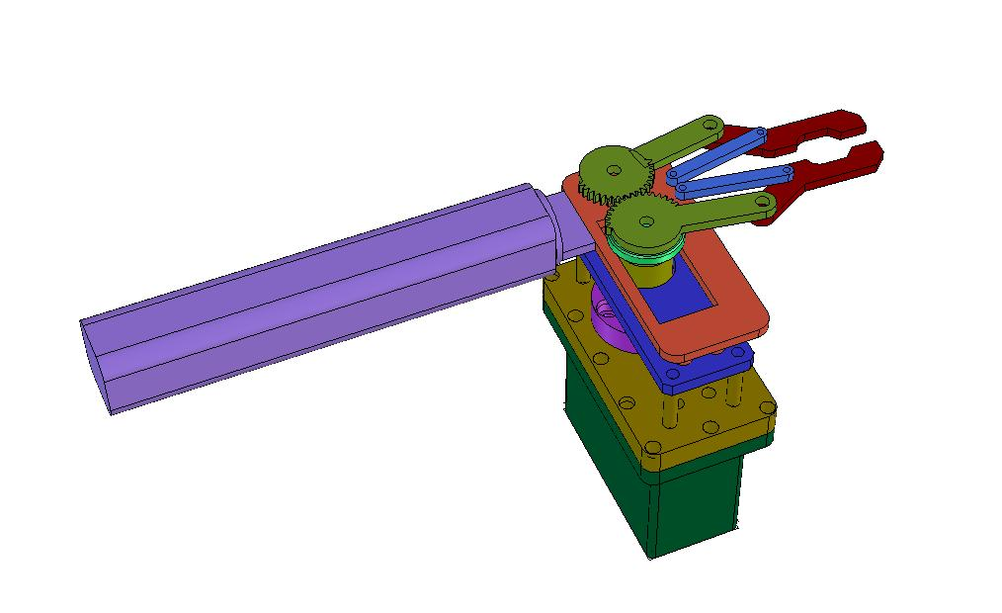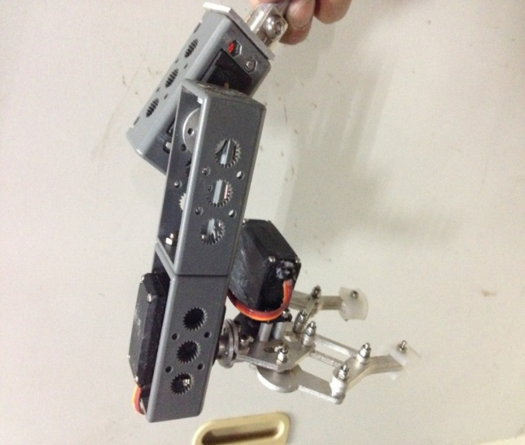



Our team made a lot of consideration in the design of safety features, because this is a very important aspect of any ROV design. The design of safety features are that each electric circuit includes fuses and we have warning sign in the dangerous places (such as: high voltage line and low line).

Once the power is on, all systems can be manipulated. Whether the ROV works or not, a series of safety tests are executed in the internal part in the design of our robot.

Before we took part in the regional contest, we had thought we already did a lot of things about safety. But when we participated in the contest, we came to realize that safety feature was so special and so important and we still need to do more about it.

In the design process, we needed to consider the problem of waterproof of the ROV. We have never met this before the competition, so it is a very difficult problem.

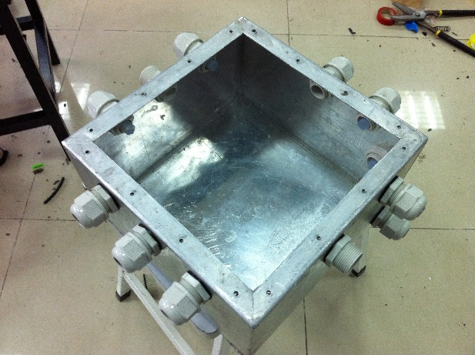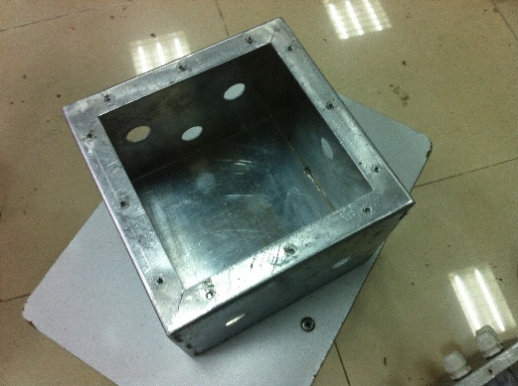 We treated the problem of waterproof very seriously from the beginning. We collected some information about underwater robot, preparing to use acrylic cylinder to make the waterproof compartment. However, due to the lack of experience, we considered the question too easy. The volume was too large for the whole and the structure was not suitable for the machine, etc. It Led to the result that waterproof compartment couldn't be done according to the design and manufacture. Having looked up the relevant literature, we redesign a silicone gasket with welding and threaded connection. The circuit is the core of the robot. It is the key to control the robot, but changing the waterproof structure was too late for the competition, the circuit was almost competed, and the waterproof structure had not been completely done. Instead, it had many problems: the aluminum box welding should be able to 4 meters deep water and the effects of deformation and stress expansion should be taken into consideration due to the line coefficient. Also, we needed special attention to this point that the processing of waterproof joint had skills. We should choose the center distance of the box cover and the thickness of Silicone gasket.

Because we did not pay special attention to this from the beginning, it caused us to waste a lot of time and energy. As it was near the date of the competition, time was our real weakness. Forgetting about eating and sleeping was quite common for us. However, we failed to solve the problem of waterproof. With the dual psychological and physiological pressure, we move roughly. At that time, we encouraged each other and gave energy to each other. Though the road was rugged, we moved roughly. We didn't care how many difficulties we might face.For the final goal---"rush to the USA",we had gone through trying hours and finally sovled the problem of waterproof.

At that time, we saw hope!

Due to budget constraints, one of the biggest challenges that the ROV engineering face was to obtain the required material. However, due to these limitations, the team members were very careful with the resources spent in school. These limitations had urged us to focus on the use of recyclable materials, reducing waste and efficiency in the development and testing of engineering.

Due to the gravity, it was important to control the device weight in the design process, ensuring that the other devices could be firmly installed in the external frame. In addition, considering the net covering on the propeller, it can not only protect the blades, but also to reduce the resistance of the net cover.

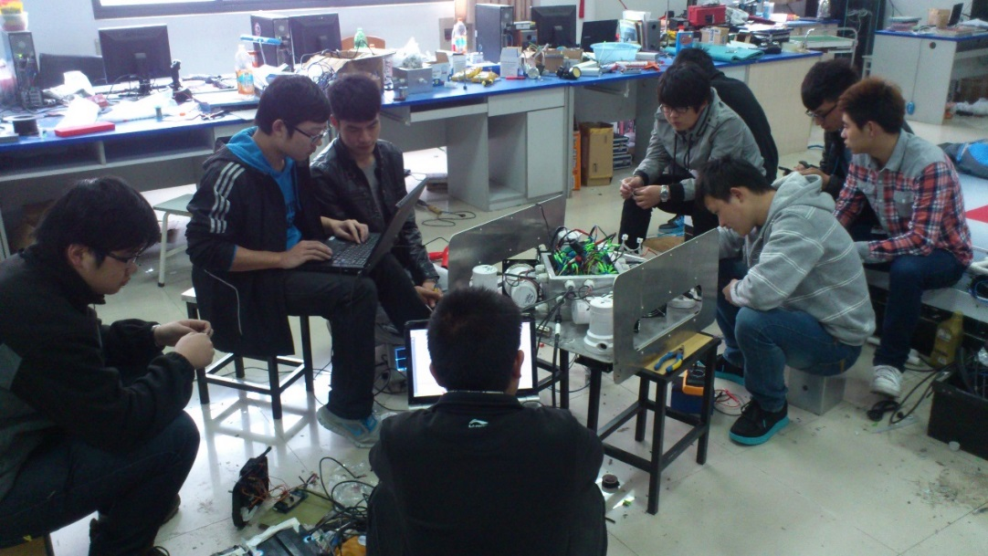Compared to the air, resistance and inertia in the water are relatively large, so the reaction speed of the robot is slow. It is difficult to adjust the robot gesture rapidly. Accordingly, the design for balance becomes difficult. For control algorithm，we learned from the four axis aircraft, and we made some improvement to the characteristics of the robot. As to sensors, we used gyroscope and nine axis sensor, which made the control more accurate.As to loction, we used pressure sensor and electronic compass device,which made the location information more accurate.

Then through the PID control, we could enter accurate data on the location and depth

are accurate.



From the construction and design work on paper in the beginning to the creative thinking adjustment in actual use in laboratory conditions, any unforeseen variables could be coped with.

There is no doubt that the team met several complex design problems in the process of designing a ROV. From figuring out waterproof technology to simplifying the control and communication, each new stage of the design process inevitably brought its own unique set of difficulties and complexs. For our team, we had solved these different problems.

ROV components were required to conduct individual tests. Once the system was integrated, all of the system also needed to be tested. For example, in the initial test, the ROV was not moving, so we were able to isolate the propulsion system. First, checked each individual thruster electronic products, such as motor driver board, board and connecting cables and ensured that the correct signal was transmitted to each of the pusher after testing on each pusherin of the software. Once this was done and we ensured that all thrusters could work, the ROV was placed into the pool, and then ROV operator controlled to ensure that it could function properly.

The whole team of deep-sea explorer is very proud. Almost everyone joining in the design has already thinking about what can be improved to deal with possible future situations.

For many people, the first thing that comes into mind is the design of a more flexible camera frame. A more flexible one means that the camera view has increased. This will make some improvements of observation function and have better vision.

In addition, many team members also hope that the next manipulator design process can have multiple degrees of freedom. This freedom can greatly increase the range of motion of the arm, finally making it to complete more complex tasks.

Drawing the electronic circuit board provides beneficial experience to us. But the most important thing is that we have the original design of the propeller. Our programmers have researched and applied new communication interface successfully. Such as I2C, SPI, RS485. They are used to establish a connection between the vehicle and the peripheral equipment.

We have developed the control stabilizing system, which allows the ROV to keep the certain depth and the angle. Of course, it can also compensate external disturbances, making the ROV easier to operate.

This is the first time for our team to design and improve the ROV. In the design and manufacture of the ROV, we have learned many lessons and enjoyed the team's strength, which can finish the job that a person cannot make.

Specifically, we understand the acceleration gyroscope sensor MPU6050, three degree of freedom mechanical system, the rationales behind them and how they can be used to control and manipulate objects.

One of the most important thing is that the team members have acknowledged effective waterproof technology. This is the most that we spend. In addition, because we use ROV cameras, sensors, motors, and the servo system, we need to pay special attention to the power distribution in the ROV. Only in this way can we improve voltage conversion system.

Because we use binocular distance measurement, our members have learned about image processing, computer vision and stereo image. They have also learned how to generate the stereoscopic images, how to deal with these images and how to determine the length of the object in the image.

Of course, we also learned valuable life skills in the process. For example, we have learnt the management of time, on the ROV efforts to study, but also how to deal with our study.

In a word, through this competition, we have improved our ability in many aspects. Life lies in the explorations!

[1] Yuru Xu Pengchao Li.The Development Trend of Underwater Robot [J].Nature Magazine 2011-June

[2] Yuru Xu Yongjie Pang Yong Gan Yushan.Su Prospect of Intelligent Underwater Robot Technology[J].Intelligent Systems 2006-March

[3] Wei Gao Zhongping Yang Rongfei Zhao Juanping Xue.Optimum Structure Design of Mechanical Arm[J].Mechanical Design and Manufacturing 　2006-Janurary

[4] Xueye Wei.Sensor and Detection Technology [M].Beijing People's Posts and Telecommunications Press 2012

[5] Ruiguang Ling.Motor and Drag Foundation[M]the third edition.Hangzhou:The University of Zhejiang press 2012

[6] Zhiqiang Zhang.Two-Wheeled Balancing Vehicle Based On STM32[J]. Electronic design engineering 2011-July

This is our first time to participate in such a large ROV competition. In general, we have achieved the target this year and the subsequent exercise results are satisfactory. We have successfully constructed the ROV---PIONEER. Although we have met many unexpected difficulties in manufacturing process, we have used a series of creative methods to solve it. In the process of experiment and test, we have got a lot of new ideas and encouragement from the results to improve and create a more high quality and elegant machine.

Besides, we filled the gap of experience in the regional contest. Before the contest, we had so many puzzles, and the contest just gave us a perfect answer. About this competition, after all, it will be the first time for us to go to America and participate in the international contest, and we know we still have to learn a lot. But we believe that we can certainly fulfill the task with the help of judgers and so many new friends from other teams!



We would like to thank the following individuals, organizations and companies for their guidance and assistance in making the ROV a reality.

The Innovation Laboratory of Nanjing Institute of Technology

Laser Cutting Department of Nanjing Institute of Technology

The Students of Art Design in Nanjing Institute of Technology

MITSUBISHI Automation System Laboratory

GE Automation System Integration Laboratory

SIMENS Automation Laboratory

Faith World Company

Nanjing Hongyuan Information Technology Company













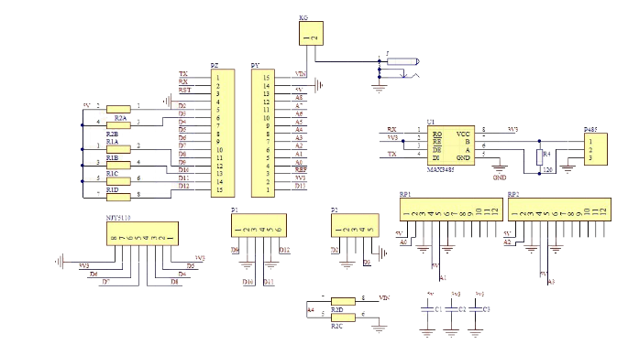

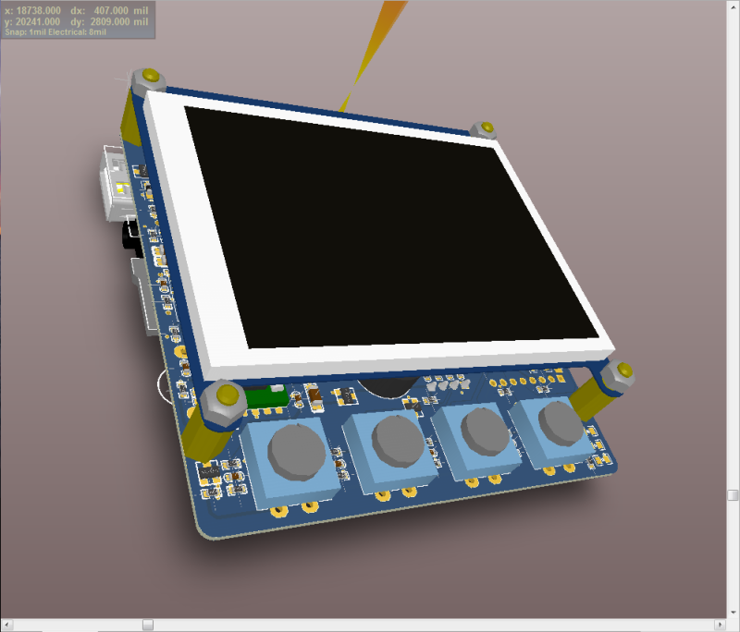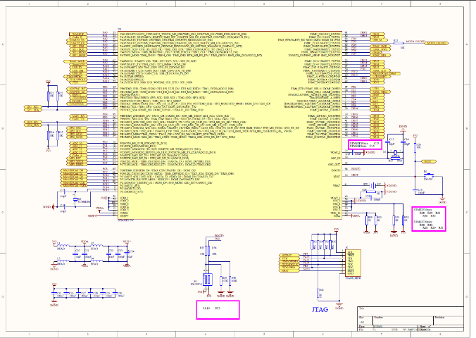Mainboard Patch Board schematic diagram MCU schematic diagram

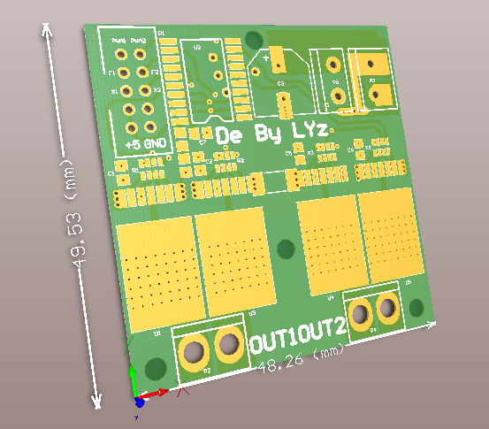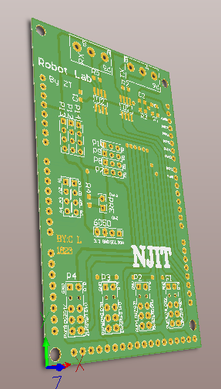 MCU Board 3D PCB

Mainboard Patch Board 3D PCB

Motor Drive 3D PCB

